Question 1: Pass/Fail Formula
Write a formula to check if the marks in cell B2 are greater than or equal to 40. If yes, return "Pass", otherwise "Fail".
Formula Used: =IF(D4>=40,"Pass","Fail")
Solution Screenshot:
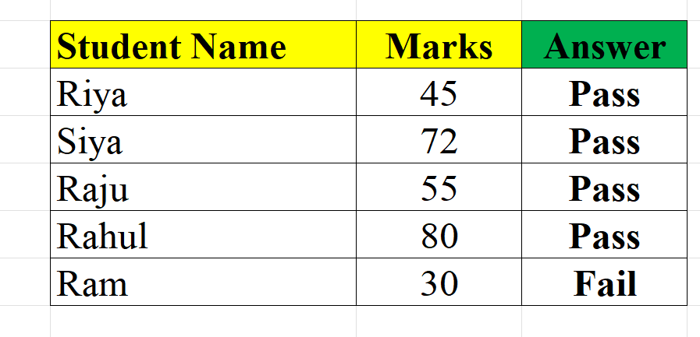

Question 2: Bonus Calculation Formula
A company gives a bonus if sales are above 40,000 and attendance is greater than or equal to 90%. Write a formula to calculate whether the employee will get a bonus or not.
Formula Used: =IF(AND(B4>40000, C4>=90%), "Bonus", "No Bonus")
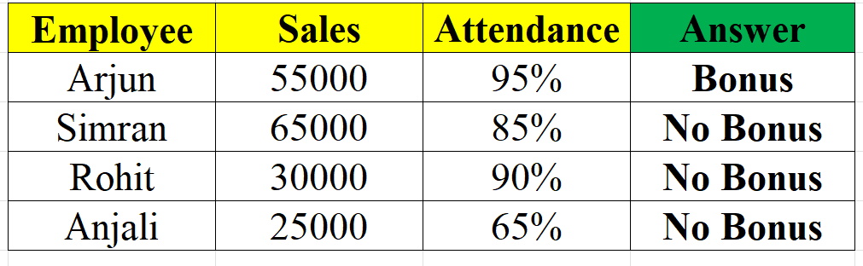
Solution Screenshot:

Question 3: Nested IF Formula for Grades
Write a nested IF formula to assign grades based on marks in cell B2, where ≥90 = "A", ≥75 = "B", ≥50 = "C", otherwise "Fail".
Formula Used: =IF(C4>=90,"A",IF(C4>=75,"B",IF(C4>=50,"C","Fail")))
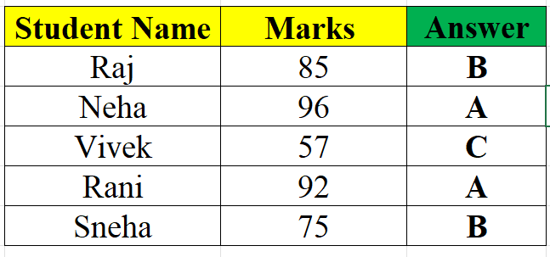
Solution Screenshot:

Question 4: Find Department using LOOKUP
Find the Department of Employee ID=E103. Also explain which LOOKUP function is used and why?
Formula Used: =VLOOKUP("E103", A3:C7, 3, FALSE)
Solution Screenshot:
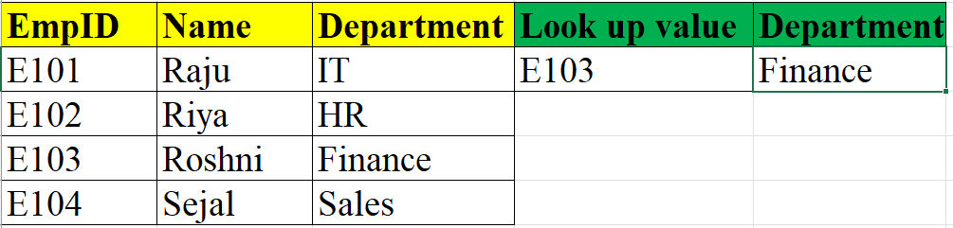

Result: The Department for EmpID E103 is Finance
Function Used: VLOOKUP (Vertical Lookup).
Explanation: VLOOKUP is used because the data is organized in vertical columns. This function allows you to search for a specific value (the EmpID "E103") in the first column of a table and retrieve a corresponding value (the Department) from a different column (in this case, the 3rd column) in the same row.

Question 5: VLOOKUP for Commission Rate
A company has set the following commission structure for its sales team: If a salesperson achieves sales of ₹45,000, use the VLOOKUP function to determine the commission rate applicable.

Formula Used: =VLOOKUP(45000,B3:C7,2,TRUE)
Solution Screenshot:
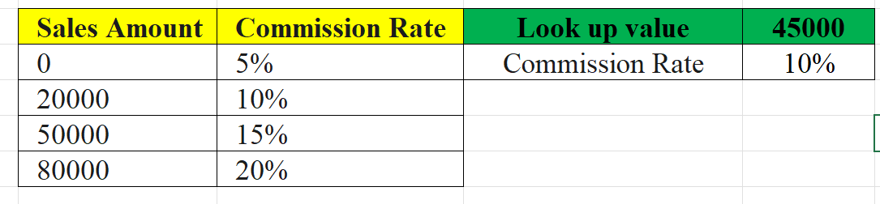

Question 6: Check Leave Balance
The HR department maintains the following leave records of employees: Write an IF function to check whether an employee has Exceeded their allowed leave balance. If Leaves Taken > Allowed Leaves, display "Exceeded". Otherwise, display "OK".
Formula Used: =IF(C3>D3, "Exceeded", "OK")
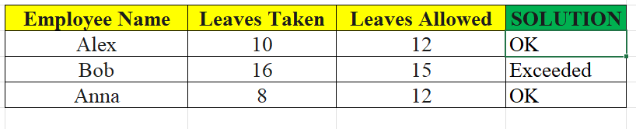
Solution Screenshot:

Question 7: INDEX-MATCH Function for Salary
Find the salary of EmpID =E105 using INDEX-MATCH Function.
Formula Used: =INDEX(C3:C7, MATCH("E105", B3:B7, 0))
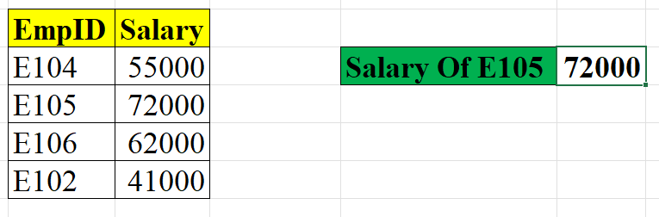
Solution Screenshot:

Answer: The INDEX-MATCH combination is used to look up a value in a column (E105) and return a value from another column (Salary) at the same position. This formula works even if the data is not sorted

Question 8: XLOOKUP Function for Department
Use the XLOOKUP function to find the Department of the employee with Emp ID $=E3O3$.
Formula Used: =XLOOKUP("E303", B3:B7, C3:C7)
Solution Screenshot:
